# Analyze a Quadratic Function

* 1. Consider the function: $f\left(x\right)=3x^{2}+6x+10$ Use the Leading Coefficient Test to determine the graph’s end behaviors. Find the vertex and the zeros using EXACT values. Identify the vertex as a maximum or minimum.

# Interpret a Quadratic Model

A ball is thrown upward and onward. The height of the ball, $f(x)$, in feet, is modeled by the function

$f\left(x\right)=-0.3x^{2}+2.1x+6$ where $x$ is the horizontal distance, in feet, from where the ball was thrown.

* 1. What is the initial height of the ball?
  2. What is the maximum height of the ball? How far along the horizontal is the ball when at its maximum height?
  3. How far does the ball travel on the horizontal before hitting the ground? Round to the nearest tenth foot.

# Interpret a Quadratic Model Eliza wants to keep her curious puppies away from her garden. Below is an overhead picture of her garden, which is pushed up against her house. She is using three rectangular sides of fencing to enclose the area and keep her puppies out. All sides are measured in feet.

house



Find a function *A(x)* to express the area of the rectangle as a function of *x* the width.

x

x

* 1. What is the maximum area that can be enclosed? Include units.

40 - 2x

Find the width that will maximize the area. Include units.

Find the length that will maximize the area. Include units.

# Know the Four Cases for End-Behavior

1. List the four-cases and describe what happens as $x→±∞$

# Find the Zeros, State Multiplicity and Identify the Shape of the Zeros

1. a) $f\left(x\right)=3(x-7){\left(x+5\right)}^{2}$ b. $f\left(x\right)=-x^{2}(x-4)(x+5){(x+1)}^{3}$

# Use the Graph to Find the Equation of the Polynomial; Leave in Factored Form

* + 1. 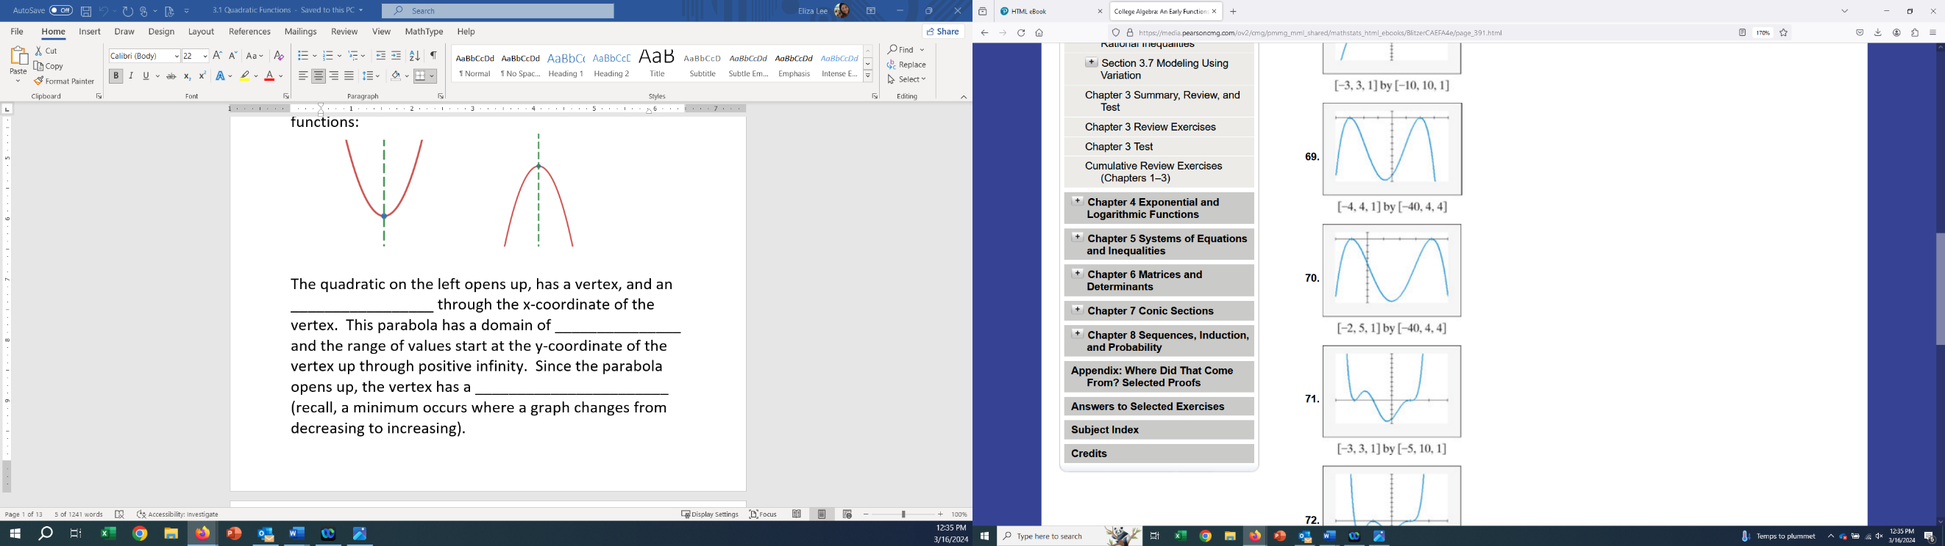Find the zeros and state whether the multiplicity of each zero is even or odd.
    2. Write an equation, expressed as the product of factors, of a polynomial function that might have the graph. Use a leading coefficient of 1 or -1 and make the degree of f as small as possible.

[-4,4,1] by [-40,4,4]

# Use Zeros to Build a Polynomial Function

Find the polynomial whose leading coefficient is either $1$ or $-1$ with the following conditions: zero at $x=-3$ with multiplicity 2, zero at $x=4$ with multiplicity 1. End-behavior Rises Left, Falls Right

# Identify Vertical and Horizontal Asymptotes

Use the graph to identify all asymptotes: Identify the domain in interval AND set notation. Find all asymptotes for the function:

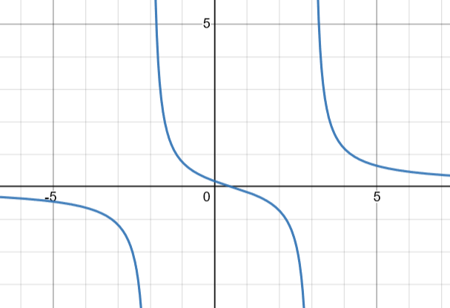 $f\left(x\right)=\frac{5x^{2}+1}{x^{2}-4}$

# Interpret a Rational Model

A drug is injected into a patient and the concentration of the drug in the bloodstream is monitored. The drug’s concentration, $C(t)$, in milligrams per liter (mg/L), after $t$ hours is modeled by the function:

$C\left(t\right)=\frac{9t}{t^{2}+3};t≥0$

What is the concentration of the drug in the bloodstream after $6$ hours?

At what time(s) will the concentration of the drug in the bloodstream be $1$ mg/L?

Write the equation of the horizontal asymptote and interpret its meaning.

# Find the Constant of Variation, $k$

1. $y$ varies jointly as $x$ and the square of $z$. $y=18$ when $x=4$ and $z=3$. Find the constant of variation. Write the general variation equation.
2. $y$ varies directly as the cube of $x$ and inversely as the square root of $z$. $y=3$ when $x=2$ and $z=25$. Find the constant of variation. Write the general variation equation.

# Solve Variation Problems in Context

The distance, $s$, that a body falls from rest varies directly as the square of time, $t$, of the fall. If a skydiver falls 64 feet in 2 seconds, how far will they fall in 4.5 seconds? Use the given quantities to solve for $k, write the general variation equation first.$

A radiation machine produces an intensity of radiation, $I$, that varies inversely as the square of the distance, $d$, from the machine. At 3 meters, the radiation intensity is 62.5 milliroentgens per hour. What is the intensity at a distance of 2.5 meters? Use the given quantities to solve for $k, write the general variation equation first.$



# Calculate the Distance and Find the Midpoint between Two Points

$(-1,4)$ and $(3,-2)$

# Find the Center and Radius of the Circle

# this is a circle with opposing points (3,3) and (11,13)Use a Graph to Find the Equation for the Circle